**Western Murray Land Improvement Group**

**Economically Viable Options for Retired Irrigation Land Project**

Walk and Talk March 22nd 2019

**Overview**

The project aims to explore, through the use of case study sites in the Wakool Shire, the biophysical and economic feasibility of various pasture species for retired irrigation lands in the Central Murray, including establishment and grazing options.

The project has two components, small plot trials to evaluate new and existing pasture species/varieties and larger areas sown to improved pasture species to test livestock performance.

The small plot trials have a couple of purposes – one to test the suitability of the species/varieties to local conditions (soil and rainfall) as well as persistence/regeneration between seasons.

The larger plots/paddocks were then established based on the results of the small plots.

Species and varieties were principally selected on their ability to grow on approximately 375mm of annual rainfall. Other criteria included the ability to tolerate heavier soil types, frost, waterlogging and persistence (either producing hard seeds or drought tolerance).

As a result, there are 4 different strategies examined in the trials:

1. Annuals that will grow, flower, seed and regenerate next season.
2. Annuals that will maximise growth from rainfall but require re-sowing each season.
3. Perennials, both grasses, legumes and shrubs that will survive the summer.
4. Experimental species (natives and exotics) that are currently undergoing evaluation.



**Expansion of the EVORIL Project.**

Funding was available to expand the project areas to enable the planting of a perennial shrub and annual/perennial pasture system. The perennial shrubs (Old Man Saltbush “Narromine”, Old Man Saltbush “Anameka” and locally sourced OMS seed that was direct seeded) were planted at 4 sites in dual rows on 13 metre centres with an annual pasture mix sown between the rows. This gives a saltbush population of 550 plants/ha and allows evaluation of the improved OMS clone “Anameka” which is claimed to be more digestible and hence more productive.

Rick has adopted a similar approach on his property. He has opted for a higher saltbush population of approximately 825 plants/m2. This results in the inter-row of approximately 7m.

Based on the results of the EVORIL project, the pasture seed mix starts with core species and can then be modified to suit a particular situation.

Core Species

Lucerne 2 kg/ha

Annual Ryegrass 4 kg/ha (If required)

Annual medics/clovers 6 kg/ha Barrel Medic

Rose Clover

Snail Medic

Spineless Burr Medic

Options Mediterranean Fescue

Arrowleaf Clover

Bladder Clover

Gland Clover

Persian Clover (hard seeded)

**Grazing Summary: Summer 2018/19**

28 ha saltbush planted 2016/17

70 kg ewes, 325 head (max)

In: October 17th Condition Score 3

Out: February 22nd Condition Score 3+

127 Grazing days (some days out of the saltbush)

Saltbush/pasture carried 7.9 ewes/ha or approximately 12 DSE

Forage consumed approximately 1800 kg DM/ha

Feed On Offer assessment on December 8th

Lucerne: 2000 kg DM/ha

Anameka saltbush: 2.6 kg/plant, 0.63t DM/ha

Narromine saltbush: 4.1 kg/plant, 0.98t DM/ha

**Pasture Species Performance**



The more ticks the better (5 maximum)

**Pasture Establishment and Management Notes**

**Preparation**

Weed control is essential prior to beginning a pasture improvement program. Barley grass control must start AT LEAST the season before you anticipate sowing as some of the EVORIL project paddocks have seen barley grass be quite a resilient weed and make a re-appearance 2 seasons later.

**Sowing**

**Higher sowing rates** cost more but grow more dry matter and compete with weeds.

Trial 1 Trial 2

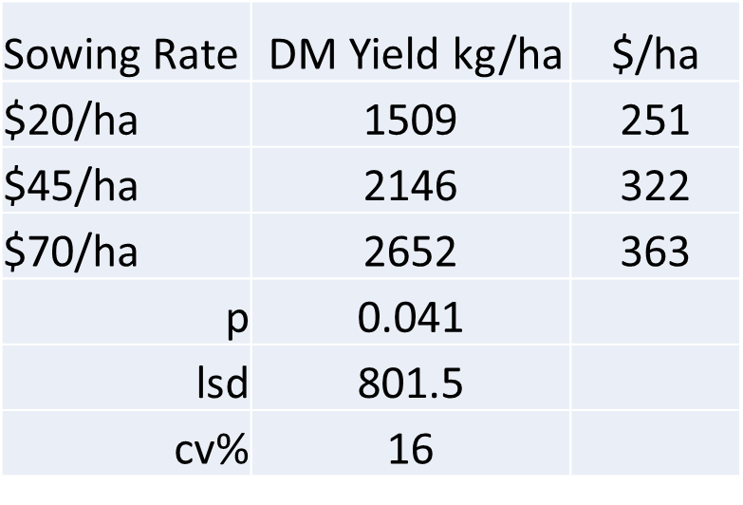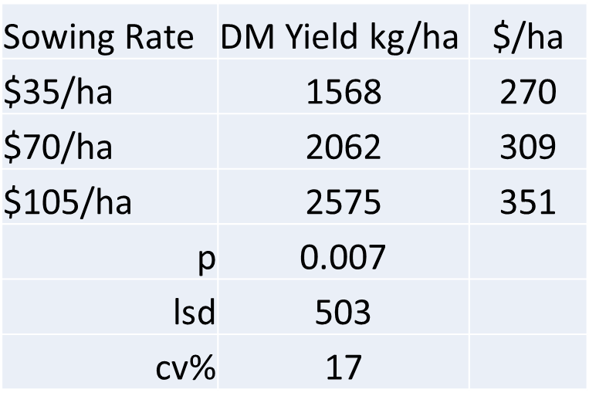

Assumes DM = $150/t

**2 year sowing program** - sow legumes first then the grasses.

This allows the clovers and medics to get established, and be able to use a (relatively) cheap Group A herbicide to control any grasses. This also allows for simple grazing management to ensure seed set of the legumes, but this comes at a cost of little return for the season. The grass(es) are then sown in Year 2.

**Managing the Pasture**

**Pest Control**

Do not sow and forget. Monitor for insects, particularly Red Legged Earth Mite and Lucerne Flea.

**Lower rates of Group A herbicides** have been used to suppress barley grass in a grass/legume pasture. The EVORIL project demonstrated the use of lower rates of the Group A herbicides haloxyfop (Verdict), propaquizafop (Correct or Shogun) and clodinafop (Topik 240).

|  |  |  |
| --- | --- | --- |
| Herbicide | Rate ml/ha | $/ha* |
| Clodinafop | 100 | $5.50 |
| Haloxyfop | 45 | $2.50 |
| Propaquizafop | 200 | $8.00 |

‘* approximate

Results from 2017 suggested propaquizafop was the best option.

Broadleaf weed control may be required. Brassica weeds, sow thistle and capeweed have been the most likely weeds. The earlier the weeds are sprayed, the easier they are to control, but keep in mind some herbicides need the clovers and legumes to be past a particular growth stage. To date, 2,4DB has been the safest “all rounder” but at $20/l or $40/ha, it is quite expensive.

Flumetsulam ($14/ha) has also been useful, but will control biserrula. Bromoxynil has also caused damage on some of the medics.

**Grazing**

**The priority of a first year pasture is seed set.** Grazing management can be useful in manipulating pasture components but allow the plants to set seed.

Seed of most of the pasture species trialled are aerial seeders (unlike subclover) and so are more prone to grazing. Some produce large pods and could be susceptible to overgrazing over summer. An advantage of aerial seeding is the opportunity to harvest your own seed. An option may be to create a “nursery paddock” where the pasture can be more carefully managed and used as a seed source for sowing the rest of the farm.

Despite the best of grazing management and seasons, some species will not be very prolific in year 2 due to their very hard seeded. This is an advantage in the longer term, as once the seedbank is established, a poor season or opportunity cropping will have only a small effect on the pasture species.

**Pasture Quality**

Pasture cuts from Murrayview 2016

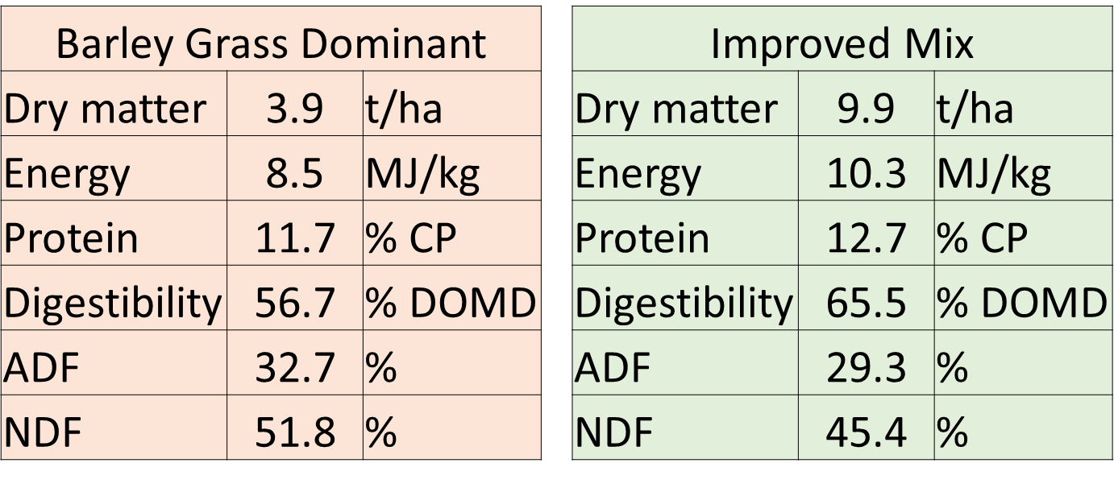

**Saltbush Evaluation**

The EVORIL site planted in 2016 at Cobramunga had the best establishment of Anameka, Narromine and direct seeded saltbush. Prior to grazing in January 2018, shoots were hand harvested from the 3 “varieties” and sent to Agrifood Technology (FeedTest) for analysis. This was repeated in December 2018, and samples from Rick’s plantings were also submitted for analysis.



While the test results are not as accurate as actual rumen testing (eg the negative effects of the high ash content), the results do allow a comparison between saltbush options.

Some observations

Anameka

Uniform plants once established

Issues with freight and the time in the boxes as the plants come from WA

Cost is considerably higher when freight is included

Variable grazing preference

Rooting issues?

Narromine

Variable plant type

Hardy plants, well packed

Direct seeded

Variable establishment

Variable plant type

Low cost of establishment