Wakool Innovation Fund
Background:
Western Murray Land Improvement Group are calling for applications from residents of the Wakool Irrigation Footprint to apply for the Wakool Innovation Fund.
Up to $25,000 is available for project/projects that contribute to an increase of on-farm efficiencies and demonstrate diversification or value adding potential or implement a new innovative technology.
This project is supported by the Australian Government’s Murray-Darling Basin Economic Development Program.

Key Selection Criteria:
The funding will be assessed on four key selection criteria based on the below:
- Increase in on-farm efficiencies
- Diversification or value adding potential
- Implementation of innovative on-farm technology
- Broader positive impact of the project/activity on other businesses and farmers in the Wakool Irrigation District

You will be asked to outline in your application how each of the criterion are met.

Funding details:
Up to $25,000 in funding is available with the total pool of funding being $25,000
The Wakool Innovation Fund Panel reserve the right to allocate funding as they choose to applicants.
For example, one successful applicant may receive the entire $25,000 or five recipients may receive $5,000 each.
Funding cannot be used to:
- Pay wages (contractors for installation of technology excepted)
- Pay lease costs
- Purchase livestock
- Performing “business as usual” maintenance work
- Purchase land
By submitting your application, you are agreeing to:
- Host an on-farm demonstration or workshop to demonstrate efficiencies or new technology open to the community to attend.
- Provide project information and results to WMLIG to produce a case study which will be supplied to the Australian Department of Agriculture, Water and the Environment.
Application Process:
There are two application stages
1. Written Application (Applications Open midnight 1st October 2021 – 31st October 2021 midnight)
2. Presentation to Wakool Innovation Fund Panel (Presentations to occur between 14th November 2021 – 28th November 2021)

Stage 1: Written application
What does it involve:
Submitting a written application addressing the below criteria and questions.
Your application include:
You will be required to include the below in your initial written application
- Overview of your project
- Budget
- Desired outcomes
- Benefit to local community
A shortlist of applicants will be contacted to progress to Stage 2.

Stage 2: Presentation to Wakool Innovation Fund Panel
What does it involve:
Presenting your project/concept face-to-face to the Wakool Innovation Fund Panel (please see below for panellists)
This will include time for Q&A from the panellists to further scope out your project.
Please note in the case of Covid-19 restrictions in place presentations may occur via video presentation.

Example Projects:
Some broad examples of projects include:
Example 1: Implementing Spray technology
Example 2: Improvements and efficiencies in irrigation infrastructure
Example 3: Investment in innovative equipment to increase livestock production

Wakool Innovation Fund Panel
The panel will be made up of 3 community members/board representatives. The decision made by the panel is final.

Timeline:
1st October 2021 | Stage 1 written application open
31st October 2021 | Stage 1 written application close
1st November 2021 – 14th November 2021 | Panel to review applications and create Stage 2 shortlist.  Successful applicants will be contacted by the 14th November
14th November 2021– 28th November 2021 | Stage 2 Presentations  (Contingency plan due to covid restrictions will be further assessment of the Stage 1 written submission and interview via video meeting)
29th November 2021 – 6th December 2021 | Panellists to assess the applications
December 7th 2021 | Wakool Innovation Fund successful applicant(s) announced

For successful applicant(s) only:
- All purchases must be made prior to 1st January 2022
- On-farm demonstration/workshop to be scheduled prior to February 15th 2022 (covid-restrictions permitting)
- Case Study to be produced by WMLIG in cooperation with the successful applicant(s) prior to March 15th 2022
Terms and Conditions:
- Please refer to the map on our website to check that you qualify as a Wakool Irrigation District. This includes any farmers, workers, landholders. This includes businesses that currently own or lease property.
- Payment will be made once the successful applicant(s) have produced receipts for their purchase(s)
- WMLIG staff members, board members and contractors will not be eligible to apply for this funding
- Any conflict of interest must be declared at the time of the application
- One application per business may be submitted

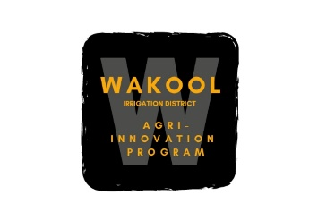
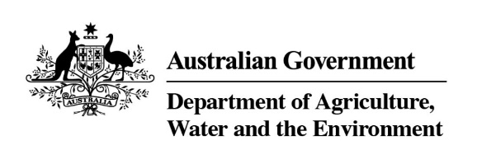
This project is funded by the Australian Government’s Murray-Darling Basin Economic Development Program.

