2 March 2015
Community Group delivers again for sheep producers

The popularity of workshops hosted by the Central Murray Bestwool / Bestlamb Group was shown when over 50 land holders attended a series of informative nights on the importance of keeping sheep healthy to maximise enterprise profits.

It was a great turnout with some landholders travelling over 100km to converge at Moulamein on Monday night and Wakool on Tuesday night, for dinner and a very informative presentation. The information was one section from MLA and AWI’s ‘Making More from Sheep’ program and was supported by Western Murray Land Improvement Group, through Murray Local Land Services.

Geoff Duddy, from Sheep Solutions took participants through the importance of being able to accurately assess sheep using condition scoring to increase ewe conception rates, lambing and weaner survival.

“A 10% increase in weaning rate will normally result in increased profit margins from 13-25%, depending on enterprise” Geoff said.

Murray Local Land Services Regional Veterinarian, Dan Salmon spoke on a host of disease related topics with a focus on how to administer treatments effectively and efficiently to reduce wasted time and money through incorrect applications.

“80% of the cost of worms is unseen. This makes it important to carefully measure and manage any internal parasite program otherwise we will have major production losses as well as worms that are resistant to drenches” Dan said.

After demonstrations of new internet based decision making tools such as Wormboss and Liceboss, the majority of participants said they would try out these tools to help them improve their drenching and other animal health programs in the future.

It’s no surprise that a large number of landholders believe the primary source of lice reinfestation on farms is due to strays from neighbouring properties, however incorrect techniques or treatments on farm is a far more common cause of lice re-infestation.

Dr Salmon took the audience through the do’s and dont’s of successful on-farm lice eradication programs to reduce the chance the treatments will fail.

He also spoke on the high level of Ovine Brucellosis previously detected in the area and the need to protect the district from re-infection which can be done by only buying accredited rams.

“Eradicating Ovine Brucellosis resulted in lambing percentage increases of 10-30% and producers being able to halve the number of rams they put out and significantly being able to reduce the length of time joining” Dan said.

Interactive keypad devices were used throughout the presentations to inform the presenters of the audience’s level of understanding and whether the information had convinced landholders to change practices. Organisers were pleased to see 100% of attendees would recommend the workshop to other producers.

The events were run through Central Murray Bestwool/Bestlamb group and were sponsored by the National Making More from Sheep program, with additional support from Murray Local Land Services.

The attending landholders represented 179,000Ha of land and 87,000 breeding ewes.

“Community groups such as Western Murray Land Improvement Group are vital for keeping landholders well informed and updated on the latest research and development” said Gen Reardon, Livestock Officer with Murray Local Land Services.

For further information on future events please contact Rick Ellis on (03) 5037 2334 or Roger Knight on (03) 5453 1577, or to learn more about the MMfS program visit www.makingmorefromsheep.com.au.

Photo: MLLS District Veterinarian Dan Salmon, takes landholders through strategies to maximise profits by eliminating ineffective treatments and practices at Moulamein on Monday evening.
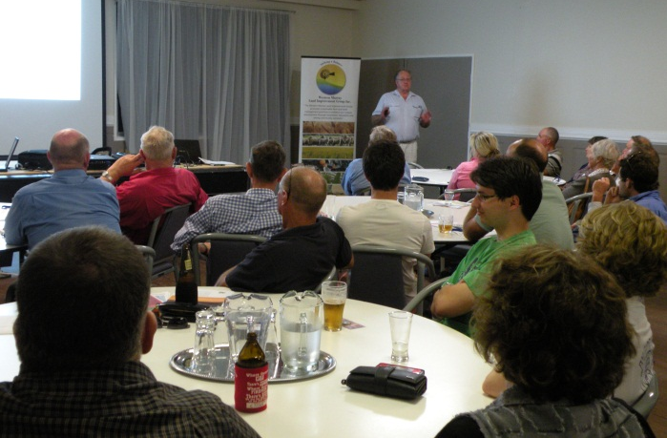

............ends ..................

For more information contact: Gen Reardon (0409 077 254) or (02) 6051 2253

